**Step 1:** Node.js installed in Ubuntu:

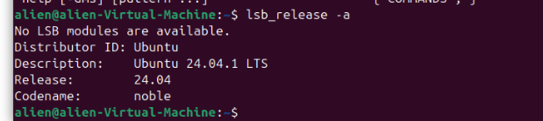

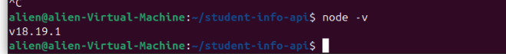

**Step 2:** **Jason-api-time-server.js** file created in the directory:

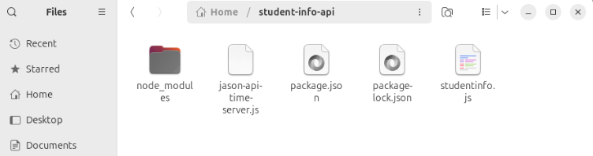

**Code Explanation:**

1. **Modules Required**:
   * We import the http module to create an HTTP server.
   * We use the url module to parse the incoming request URLs.
2. **Creating the Server**:
   * We create an HTTP server using http.createServer(). Inside the callback, we handle incoming requests.
3. **Parsing the Request**:
   * The req.url is parsed using new URL(), which gives us an easy way to access the path and query parameters.
   * We check if the path matches /api/parsetime or /api/unixtime and extract the iso parameter.
4. **Handling the Endpoints**:
   * For /api/parsetime, we create a response object containing the hour, minute, and second extracted from the date.
   * For /api/unixtime, we return the UNIX timestamp in milliseconds.
   * If the path is invalid or the iso parameter is missing, we respond with a 404 error.
5. **Response Headers**:
   * We set the Content-Type header to application/json for JSON responses.
   * We end the response with JSON.stringify() to convert our response object into a JSON string.
6. **Listening on the Specified Port**:
   * The server listens on the port specified in the command line argument.

**Step 3:** Run **json-api-time-server.js** file and specify the port:



**Step 4: Testing the Endpoints:** [**http://localhost:8000/api/currenttime**](http://localhost:8000/api/currenttime)

